|  |  |  |
| --- | --- | --- |
| Web Design. | March 13  2016 | |
| **Simple Programs:** | | Unit: ICAWEB502A |

Peter Petersen – 4101833111  
17 Indigo Crescent - Annandale  
Townsville 4814.  
Mobile-0451919894

Input: Create Dynamic Web Pages.

Contents

Task 1 - Setup and test the development environment 3

Organize access to a web server. 4

Create a test web page and load it onto the server 4

Task 2 - write a report on the development environment 5

Write a report on the development environment. 5

Task 3 - Develop dynamic website content 9

Task 4 - Test the website and write a test report 14

Figure 1 Google Chrome 5

Figure 2 Firefox 5

Figure 3 Dreamweaver CC 2015 7

Figure 4 USBWebserver 7

Figure 5 Xampp 8

Figure 6 PHPMyAdmin 8

Figure 7 Firefox icon Figure 8 Google Chrome Icon Figure 9 Internet Explorer Icon Figure 10 Adobe Photoshop Icon 8

Figure 11 Sublime Text Editor 9

A proposed folder structure for your website Figure 12 Folder Structure 9

Figure 13 Mailing list option 10

Figure 14 Mailing List Code 12

Figure 15 Flipping Left Logo 12

Figure 16 Left Logo Returned 12

Figure 17 Script for Flipping Logo 12

Figure 18 Dynamic Background Changes 13

Figure 19 Background Change2 13

Figure 20 Background Change3 13

Figure 21 Background Change 4 13

Figure 22 Dynamic Script for BG Changes 14

|  |  |  |  |  |  |  |  |  |  |
| --- | --- | --- | --- | --- | --- | --- | --- | --- | --- |
| **Student Name:** | | | Peter Petersen | | | **Student Number:** | | | 4101833111 |
| **Unit Code/s & Name/s:** | | | ICAWEB502A: Create Dynamic Web Pages | | | | | | |
| **Assessment Description:** | | | Practical Assessment | | | | | | |
| **Assessment Due Date:** | | |  | | **Assessment Received Date:** | | |  | |
| **Student Declaration:** I declare that this assessment is my own work. Any ideas and comments made by other people have been acknowledged as references. I understand that if this statement is found to be false, it will be regarded as misconduct and will be subject to disciplinary action as outlined in the TAFE Queensland Student Rules. I understand that emailing or submitting this assessment electronically confirms my assent to this declaration in lieu of a written signature. | | | | | | | | | |
| **Student Signature:** | |  | | | | **Date: / /** | | | |
| **Assessor Feedback:**  **Student provided with feedback** | | | | | | | | | |
| **Attempt 1 Satisfactory  Not Satisfactory  Date:      /     /** | | | | | | | | | |
| **Attempt 2 Satisfactory  Not Satisfactory  Date:      /     /** | | | | | | | | | |
| **Assessor Name:** |  | | | **Assessor Signature:** | | |  | | |
| **Note to assessor: Please record any adjustment below that has occurred to this assessment e.g. Oral questions were used to support student’s ability to complete tasks identified.** | | | | | | | | | |
|  | | | | | | | | | |
| **Disclaimer:** TAFE Queensland North (TQN) is collecting the information on this form for assessment purposes. Only authorised Departmental officers have access to this information. Your personal information will not be disclosed to any other third party without your consent, unless authorised or required by law, in accordance with the Information Privacy Act 2009. | | | | | | | | | |

**This section must be completed by the student when the student either posts or hands a completed assessment/assignment to customer service centres. a receipt is only issued for face to face assessments when requested by the student.**

✀ **RECEIPT**

|  |  |  |  |
| --- | --- | --- | --- |
| STUDENT TO COMPLETE | |  | OFFICE USE ONLY |
| Unit of competency code/s:__________________ | |  |  |
| Assessment item/No: ______________________ | |  | Date received: / / |
| Student’s name: __________________________ | |  |  |
| **Instructions to Student:** | **Time allowed:** This assessment is to be completed over the semester.  **Materials and equipment to be supplied by the Student:**   * Access to a PC, Web Authoring Tools, web server and hosting.   **General Instructions:**   * You will need access to the AllStyles Design Brief * You have 4 tasks to complete. * You will need to answer **all** questions correctly * Keep a copy of all assessments as you will be required, to submit them as a zipped file to your teacher.   NOTE: If you are not successful on your first attempt, you will be given comments and a further two weeks to rectify the changes.  You will need to re-submit your corrections for remarking. If you are unsuccessful on your second attempt, you will be required to re-enrol in this unit. | | |
| **Instructions to Assessor:** | Please see Instructions to Student above. | | |
| **Assessment Context and Description: (if required)** | In order to gain competency in ICAWEB502A: Create Dynamic Web Pages, successful completion is required of the following assessments items:   * Practical Assessment | | |
| **Note to Student:** | An Assessment Matrix is available from your teacher upon request. The matrix shows how the knowledge and skills that you are being asked to demonstrate align to the Elements, Performance Criteria, Critical Aspects, Required Skills and Required Knowledge components of each Unit of Competency. | | |

**Project**

You should create a new folder called '**complex_dynamic_webpages** and save all files in this folder. You should create sub folders as necessary.

The website must display designs, a description of the designs and photographs. Customers should be provided with the ability to complete and email and order form and add their details to a mailing list.

## Task 1 - Setup and test the development environment

You are required to setup and test the development environment. You should document the following and include this in your report:

### Organize access to a web server.

While developing the website I had access and used two separate programs to aid myself in the developing stages of the website. Because I didn’t have access to a physical webserver in class the only option was to use a Virtual server program called Xampp which was loaded onto a Windows based workstation and used in conjunction with VMware software.  
While at home I used USB Webserver software which is an easy to use server package that integrates Apache, MySQL and PP, including PHPMyAdmin. A perfect tool to show an offline version of any website, anywhere and anytime while PHP development and Website testing.

Create a test web page and load it onto the server - Create a screen dump of this page.

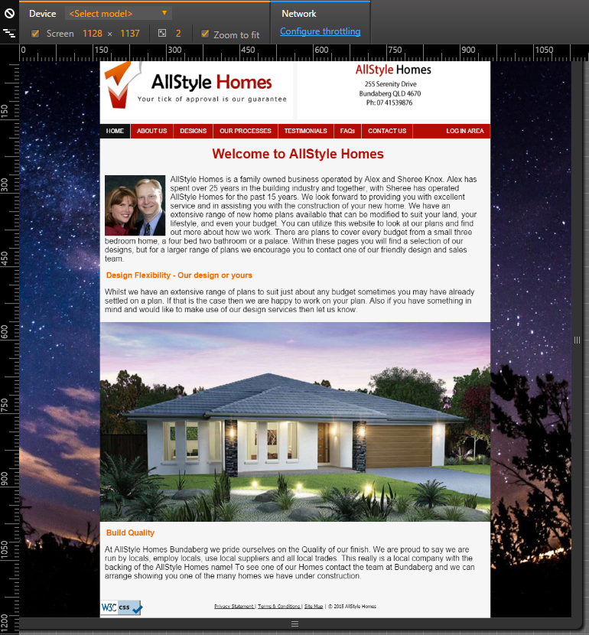

Figure 1 Google Chrome

Figure 2 Firefox

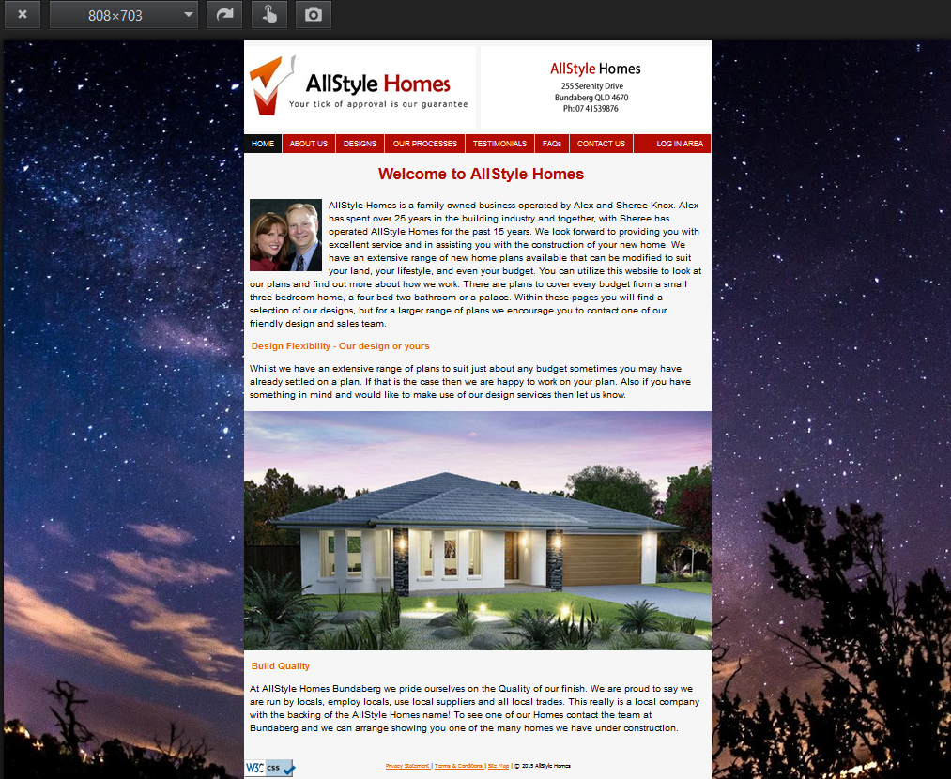

## Task 2 - write a report on the development environment

You are required to write a report detailing the requirements for the development environment. You should:

Write a report on the development environment.   
The report should include: A description of the hardware and software used in the development environment

The hardware used during the development stages of the website were as follows.

**Hardware:**

* Desktop Workstations.
* MSI Laptop.
* Keyboard and mouse.

**Software:**

* Adobe Dreamweaver Creative Cloud 2015.
* USB*Webserver* V8.6
* Xampp V 3.2.2
* PHPMyAdmin
* Mozilla Firefox Browser
* Google Chrome Browser
* Internet Explorer Browser
* Adobe Photoshop
* Sublime Text Editor

Figure 3 Dreamweaver CC 2015

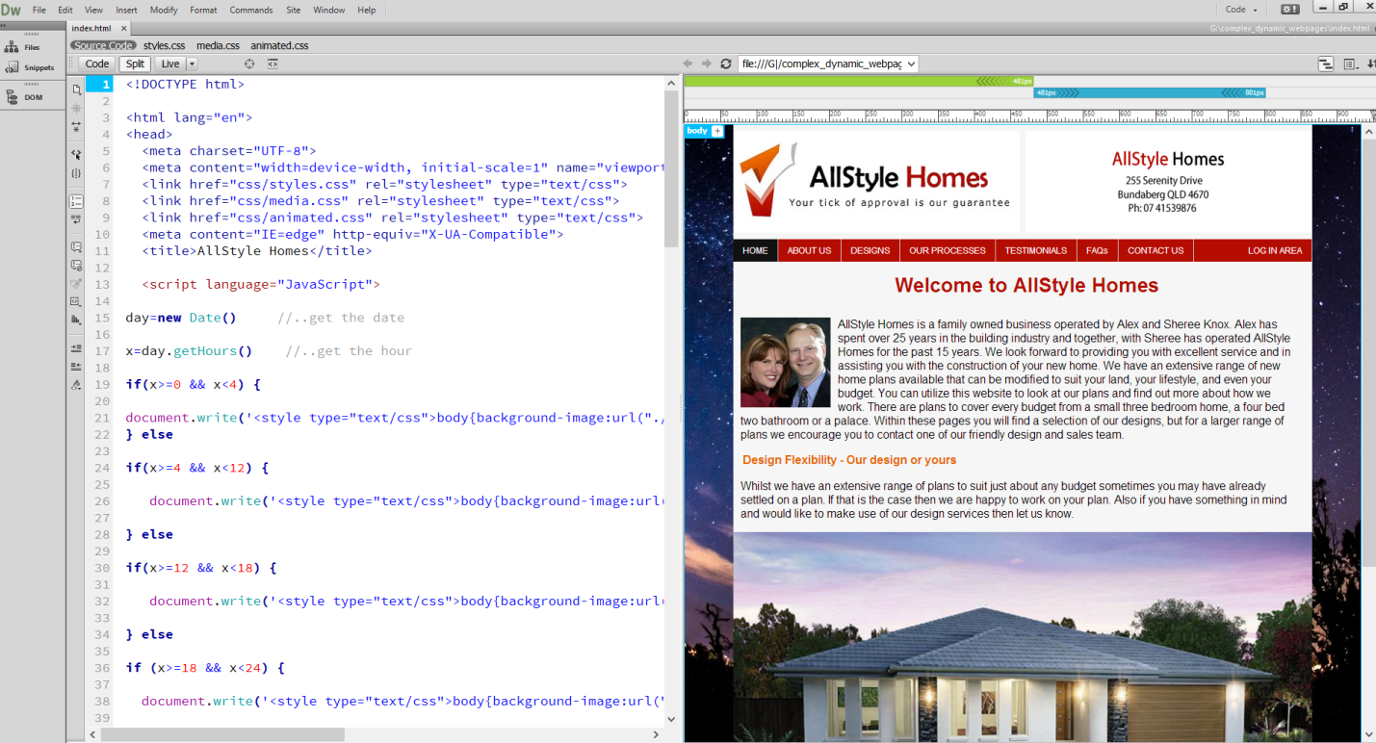

Figure 4 USBWebserver

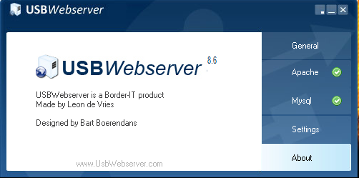

Figure 5 Xampp

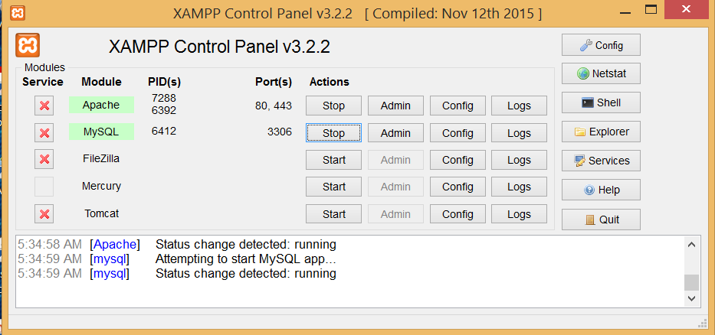

Figure 6 PHPMyAdmin

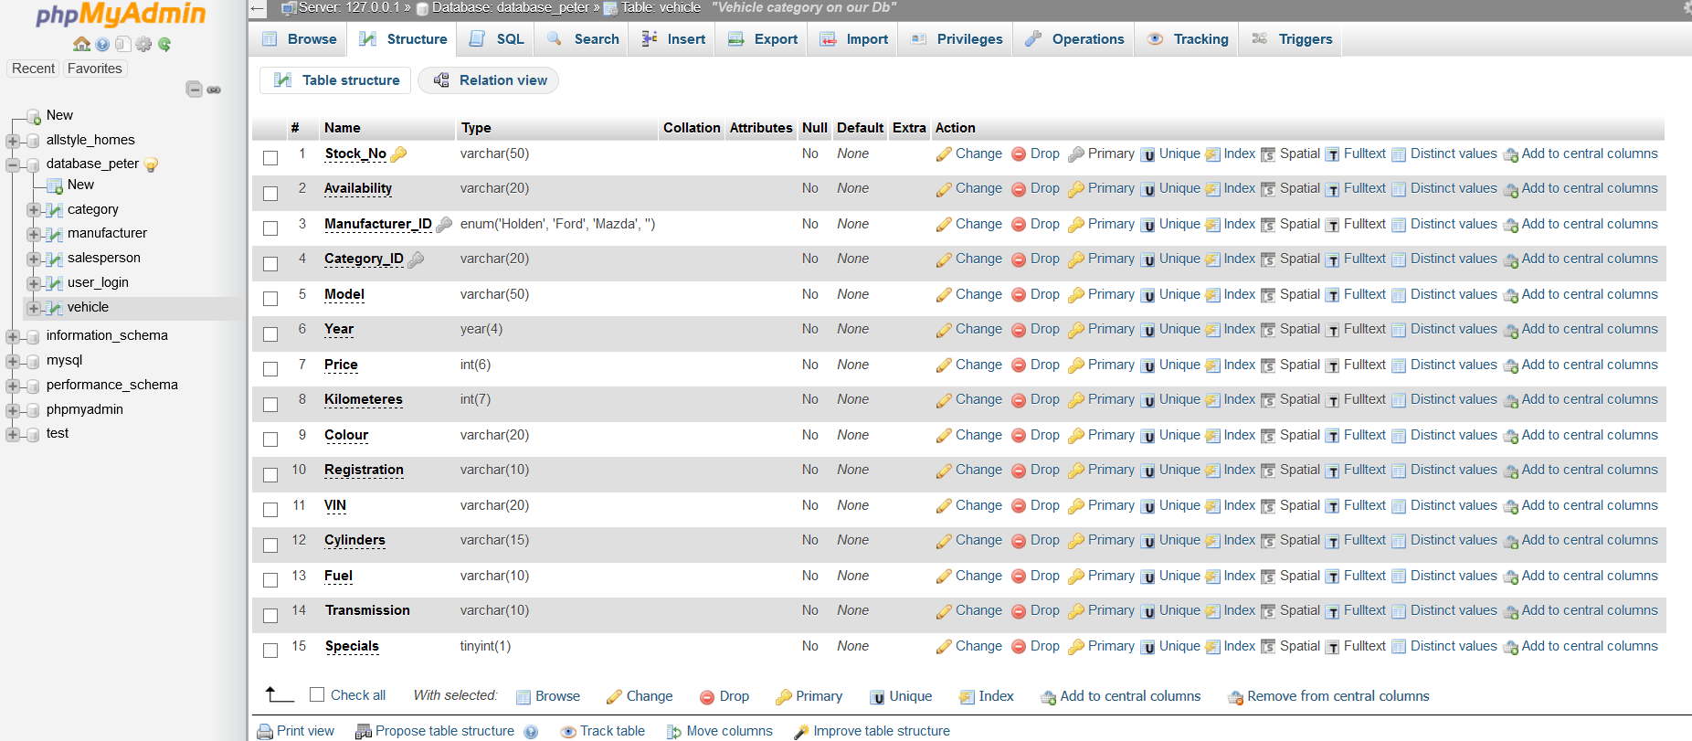

Figure 7 Firefox icon Figure 8 Google Chrome Icon Figure 9 Internet Explorer Icon Figure 10 Adobe Photoshop Icon









Figure 11 Sublime Text Editor

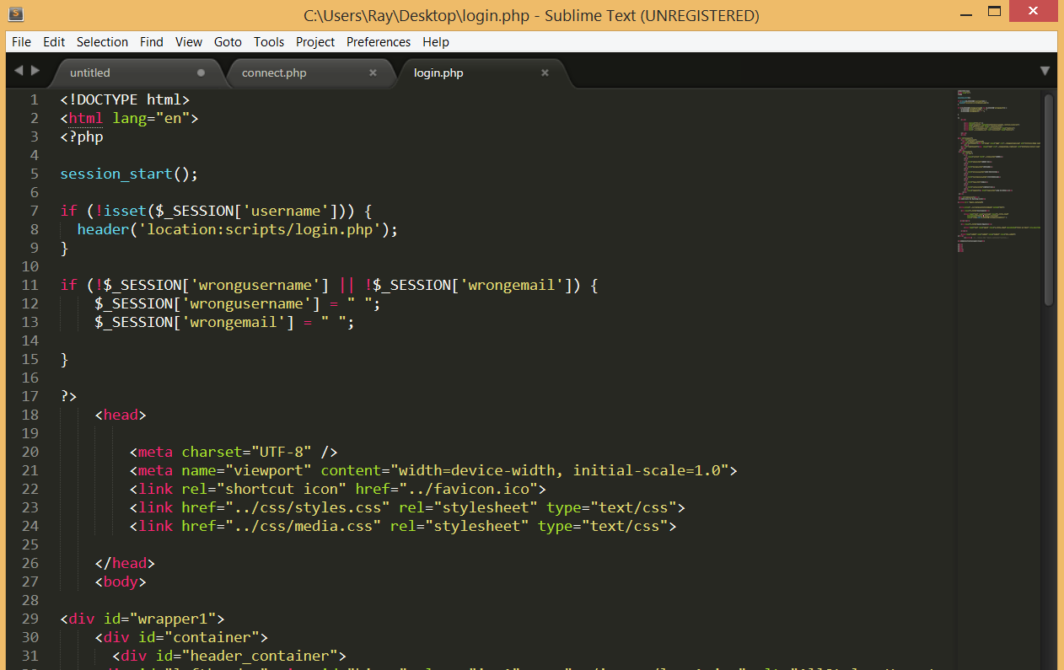

Describe who would be required to have access to the web server and why.

A Network Administrator should have access to all network resources including servers to maintain connectivity and access.

A staff member should be appointed the task of maintaining the website and will require the need to access the server and database to make amendments to relevant table structures as required.

A proposed folder structure for your website

Figure Folder Structure

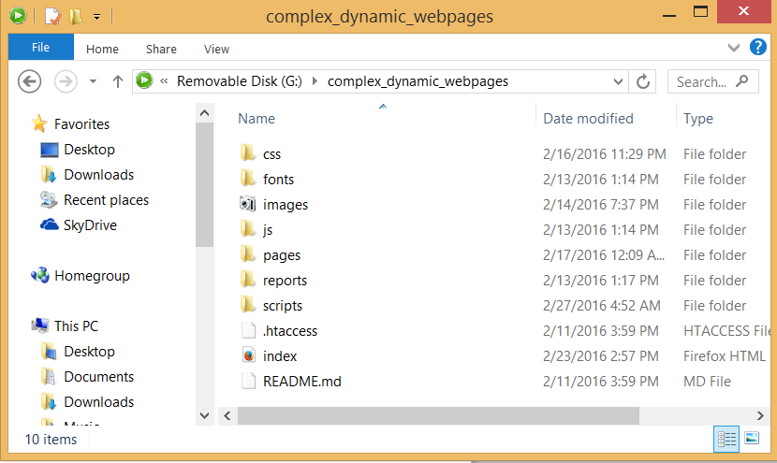

### Task 3 - Develop dynamic website content

In the last topic you began development of a site for a client. For this task you are required to develop some dynamic elements for the site. You will need to document and include this in your report. You should develop dynamic content as follows:

* Ensure that you include:
  + Facility for customers to add their name to a mailing list. You must include code to validate the fields of the form. This code must include:
    - Variables and arrays
    - Functions which use arguments
    - String functions
    - Conditionals (if/else statements)

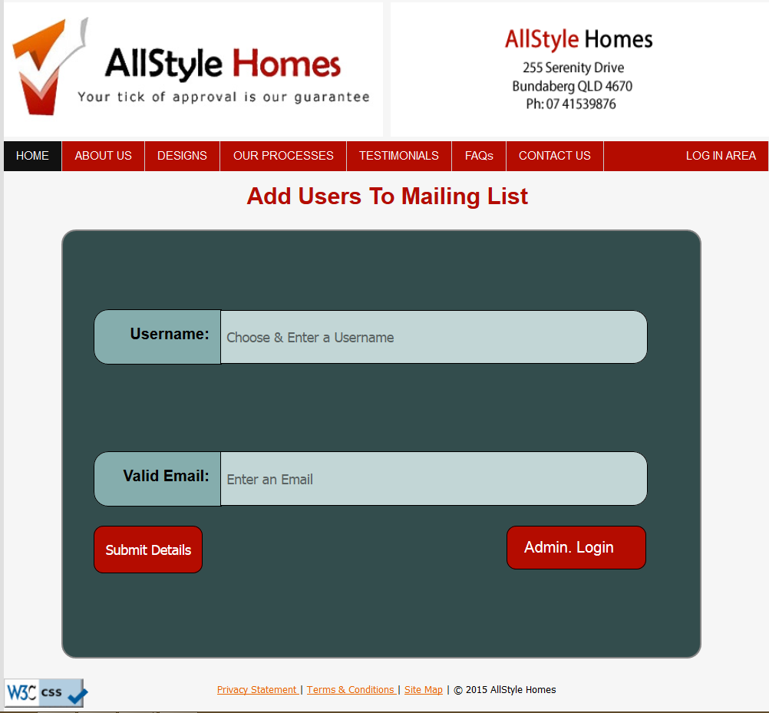

Figure Mailing list option

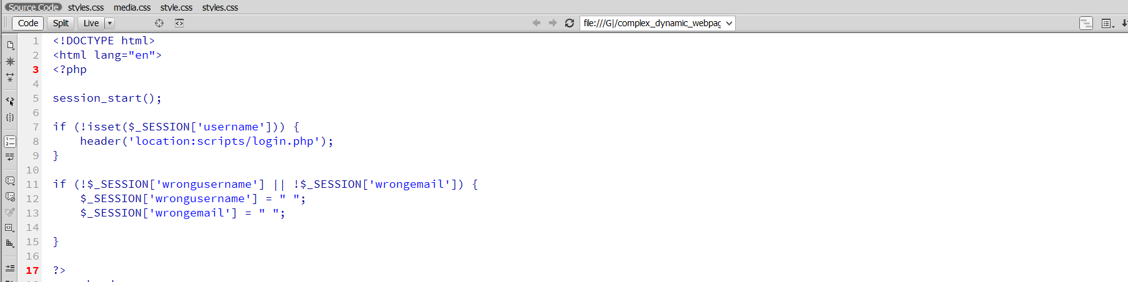

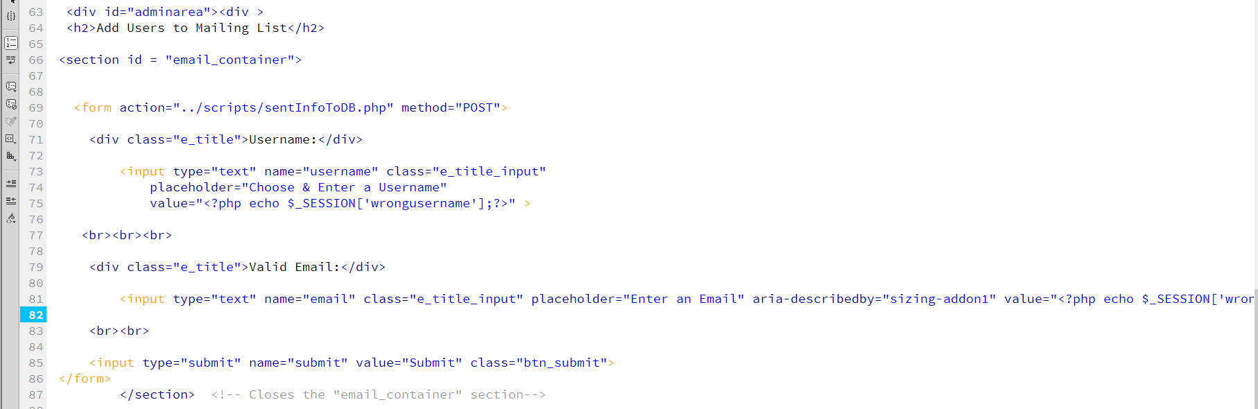

Figure Mailing List Code

* + You must include two (2) dynamic contents in your website. This can include any of the features that you have learnt. For example scrolling text or animation.

Figure Flipping Left Logo



Figure Left Logo Returned



Figure Script for Flipping Logo

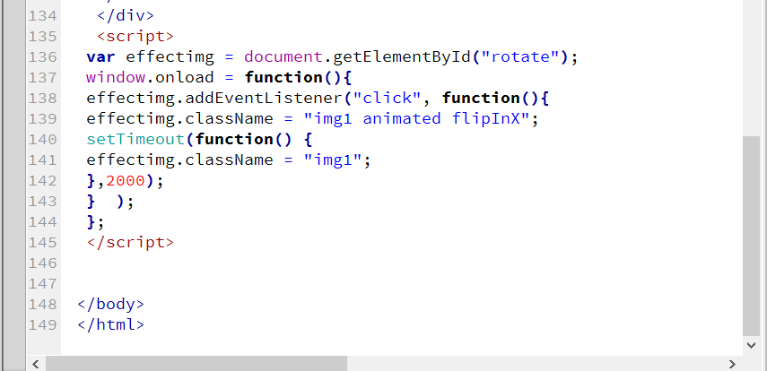

Figure Dynamic Background Changes

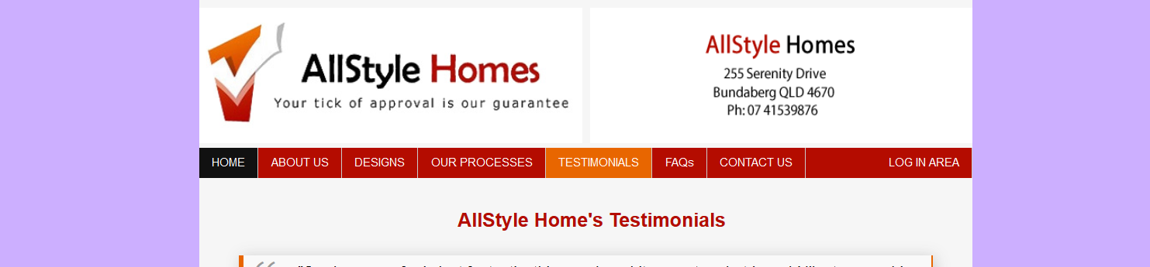

Figure Background Change2

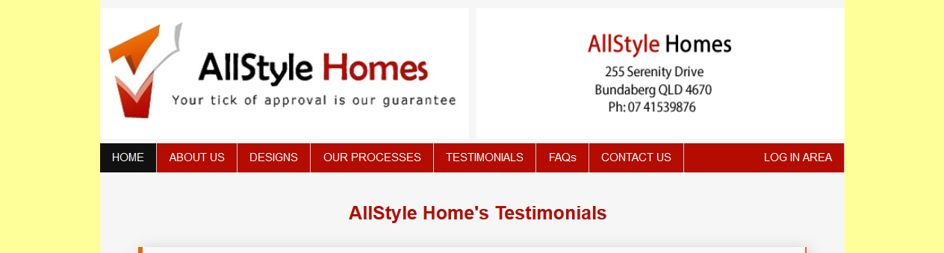

Figure Background Change3



Figure Background Change 4

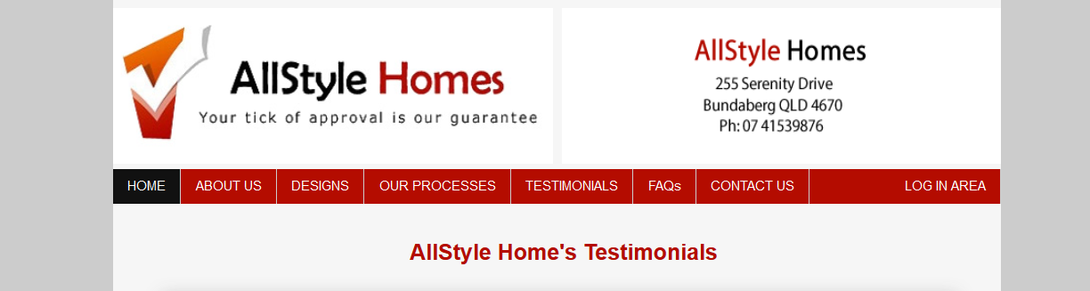

Figure 22 Dynamic Script for BG Changes

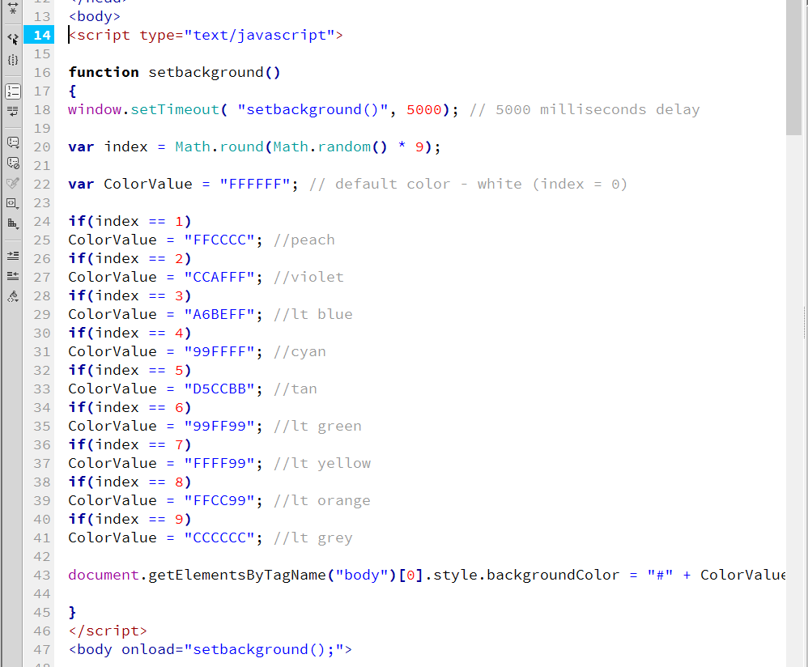

* + Develop the site (using JavaScript or some other method) to determine the time of day and change the css to display a night time viewing style.

## Task 4 - Test the website and write a test report

You are required to test your website in the development environment and write a brief test report. You should:

* Re-validate your pages
* Re test to ensure Test the website to ensure it meets accessibility standards including visual impairment
* Load your pages to the development web server
* Create a screen dump of the home page
* Test all pages work as required
* Write a report describing:
  + The test procedures used
  + Results of usability testing
  + The folder structure used
  + Include the screen dump of the home page